ODDINGTON AND WORLD WAR 1.
1914 -1919
1914
- Germany invades Belgium and on 4 August Britain declares war on Germany.
- On 7 August, four divisions making up a British Expeditionary Force crossed to France to attempt to halt the German advance. With French forces, they were successful in achieving their objective at the Battle of Mons (August) and the Battle of the Marne (September).
- Japan joins the Allied forces and the Ottoman Empire soon joins the Central Powers.
- War spreads to the seas.

CHELTENHAM CHRONICLE SEPTEMBER 12TH 1914

RECRUITING AT ODDINGTON
A very enthusiastic meeting was held at Oddington School room presided over by the Rector, on Thursday evening September 3. The speakers who kindly came forward to appeal to the patriotism of their hearers were Sir Alfred Chalmers and Sir Henry Conynghame. The first named careful explained how the war was brought about, and its seemingly small beginnings, and then went on to illustrate from history how England again and again had stood for freedom and liberty as she was doing at this time. Sir Alfred concluded a vigorous speech by appealing to the fighting instincts of the county, which had in days gone by so valiantly upheld England’s honour along with the neighbouring counties of Somerset and Devon.
Sir Henry Conynghame’s eloquence did not fail to elicit frequent approval as he detailed incidents of the war, the present position, and the need for recruits of the best calibre such as he saw before him. It was a time when all classes should stand shoulder to shoulder; and as to Oddington the gentry there had all of them given of their best for their country’s cause, so ha bade others follow the lead given. Sir Henry was able to combat the contention that the risks of fighting were so great by giving statistics showing the greater dangers attending such a peaceful occupation as mining, which had a larger death toll than that of a soldier.
At the close of the proceedings hearty cheers were given for the speakers as they passed out of the room. Eight young men came forward, took the oath of fealty and were informed by the recruiting sergeant from Chipping Norton that they would very shortly hear when and where their services would be required. More were expected to respond to from the parish to Lord Kitcheners’s appeal for more men. Several others had already enlisted.
A party of six recruits from Oddington left Adlestrop station for Bristol on Tuesday morning. The total number from Oddington who have enlisted from Oddington who have enlisted in Kitchener’s Army is eight, their names being Messrs Horace Bustin, Hubert Gorton, Ben Hale, Charles Surch, Ephraim Miles, Frederick Ridley, Arthur Williams and Walter Williams.

CHELTENHAM CHRONICLE. SEPTEMBER 1914
ODDINGTON MEN SERVING THEIR COUNTRY
The village of Oddington has several men now serving their country and one, Lieut Mervyn Johnson (South Wales Borderers) is reported severely wounded. Mrs Johnson has three other sons engaged – Capt Johnson (5th Gloucester Regiment,) Capt Dudley Johnson (South Wales Borderers) and Midshipman J C E A Johnson (RN HMS Carnarvon). Rev T Hodson and Mrs Hodson have three sons engaged – Lieut Commander Gerald Hodson (HMS Blake), Mr Hubert Hodson (who is in the Canadian Expeditionary Force) and second Lieut F L C Hodson (Gloucester Regiment). Mrs Lindsey has a son – Lieut Humphrey Lindsey – with the Kings Own Borderers - and others connected with the village who also hold commissions are Capt Reginald Lee (Queens Surrey Regiment, Lieut Brian Wingfield (RN a son of H Wingfield Oddington Lodge) and Commander H L L Pennell RN. In the ranks those serving their country are Adrian Miles (RN), Fred Wood (Territorials), Isaac Miles, Mark Green, Ronald Hope (Regular Army) Arthur Page (Resevist) and Ephraim Miles, Walter Willaims, Fred Ridley and Ben Hale (Kitcheners).

An Oddington recruit writing home to his parents from Abbey Wood refers to the good treatment the recruits are receiving. He says ‘They gave us two good white Witney blankets. We are under canvas here but we have a board bottom and it is all right, Some of the London fellows go about with long faces but that’s not good. They think they joined for a holiday but they made a mistake. I think this all right.’

The 1st South Wales Borderers. A personal report written in September 1914 and attached to the War diary as an appendix.
Wednesday 16th Sept 1914. I have never spent and imagine that I can never spend a more ghastly and heart tearing 48 hours than the last. …we have been fighting hard ever since 8am on 14th….The 2nd Brigade is already engaged and we are sent to the high ground to the left to assist them. As we go we get some six shrapnels at us but mercifully are not touched. We reached shelter of high ground and take up our position. Shrapnel and fire fairly heavy. The first casualty is my mare who was shot in the head. Nothing very bad at present and she is able to go on carrying my stuff.
It is a high ridge opposite that we have to go for and nasty work it will be. Jenkinson, the Brigade Major, is killed, poor fellow, and soon afterwards we begin to suffer in the woods, chiefly from ricochets. We get several men down with small wounds, and then C Company goes to attack. Lieutenant Mervyn Johnson of A shot through the body. We hope he is not mortally wounded, but feared he is. C,D and A companies go out, leaving B in support. Swarms of Germans on the ridge, rather massed. Our guns opened on them at 1800 yards and one can see a nasty sight through one’s glasses. Bunches of Germans blown to pieces.
We again suffered some casualties and eventually had to retire. Here we stay firing and being fired at for some 8 hours. Meanwhile our guns are having a huge duel. Not much success, and Germans are too numerous to really push back properly. Several men killed.
CHELTENHAM CHRONICLE 3 OCTOBER 1914
Mrs Johnson of Oddington has received a letter dated September 17th from Rev J D Parry Evans, Chaplain to the British Forces in France, stating that her son Lieut. Mervyn Johnson who was wounded on September 14th in the battle of the Ainse was brought to a base which is being used as a temporary hospital where he died of his wounds. The Rev Parry Evans adds that he performed the last rites of the church to him and buried him with two other officers. The late officer was 28 years old and educated at Bradfield College. He joined South Wales Borderers about seven years ago. He was on leave from China when war broke out but volunteered for active service with 1st battalion and went with them to the front.

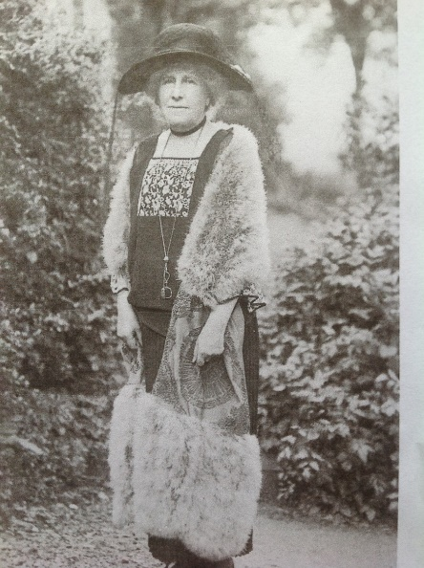
Mrs Rosina Johnson

MERVYN JOHNSON
Lieutenant South Wales Borderers. Born 1886. Died of wounds 14 September 1914.
Son of the late Cpt William and Rosina Johnson, Fern Bank, Oddington
Was serving in Tienisin, China but home on leave at outbreak of war. Volunteered for active service with 1st battalion and went to front with them.
Buried at Vendresse British Cemetery, France.

MARK GREEN
Private Gloucestershire Regiment. Born 1894. Killed in action 29 October 1914.
Son of Mrs Alma Green, Church Place, Lower Oddington
Commemorated on the Menin Gate.

