ODDINGTON WOLRD WAR 1 ARCHIVE

1917
- In February, the German Army executed a strategic retreat to pre-prepared positions, known as the Hindenburg Line.
- In Russia Tsar Nicholas II was forced to abdicate (February/March) and a Bolshevik regime under Lenin was established in October/November. This took Russia out of the
- On 6 April the USA declared war on Germany. The Allied forces co-ordinated a major push from the spring at the battle of Arras. In July, battle was again joined at Ypres (Passchendaele), where mustard gas was used in an attempt to break the lines.
- At Cambrai, a mass use of tanks was employed for the first time. Although significant ground was taken by the use of the tanks, a German counter-attack later in the month retook all that had been gained earlier.
- On 17 June, the British royal family changed their surname to Windsor to appear more British.

RICHARD DUCKERING
Private. Oxfordshire and Buckinghamshire Light Infantry. Killed in action 3 May 1917. Born Cosley Staffs. Lived in Oddington.
Commemorated on the Arras Memorial, France.

JOHN GORTON
Private. Middlesex Regiment. Killed in action 4 August 1917
Born in Oddington. Son of Phillip and Amelia (nee Cooper). Lived in Hove, Sussex.
Commemorated on the Menin Gate memorial.

LEONARD HEMMING
Private Royal Warwickshire Regiment. Died 24 September 1917.
Son of Arthur John Hemmings born in Oddington and married Alice (nee Williams) of Oddington. Living in Shipston on Stour in 1911. Various members of his mother’s family were in the village after the war and Leonard was cousin to Ralph Williams who was also killed in the war.

ARTHUR WILLIAMS
Lance Corporal, Oxfordshire and Bucks Light Infantry. Killed in action 28 April 1917.
Born Oddington. Resided Upper Oddington. Son of James and Hannah Williams of Oddington.
Commemorated on the Arras Memorial, France.

RALPH WILLIAMS
Private Wiltshire Regiment Died 10 June 1917.
Born in Oddington, son of James and Elizabeth Williams of Lower Oddington. Lived in Moreton-in-Marsh.
Buried in Oostlaverne Wood Cemetery, Belgium.

Letters from Arthur Talbot to his mother describing the event for which he was later awarded an MC and a Croix de Guerre.
22 June 1917
My Dearest Mother
Since I last wrote I have had the most strenuous Times. All yesterday we were intermittently blown about by the Boche which is perhaps in the ordinary course of events. However, we had rather an extraordinary mid-summer-nights-dream, as the Boche elected to bring off the most vicious raid on our Farm!
He began at 1 AM by about ½ hour of bombardment with every kind of frightfulness, the like of which I have never imagined, much less experienced. Then when out trenches were reduced to a stated (sic0 of being more or less ‘non est’ he attacked. Nearly all the men were blown up so we have very few left – However all is well that ends well and we eventually got back to our old positions. I will give you full details later, as I am feeling rather vague at present!!! We lost about 40%. My only damage was a tiny splinter in my face which hardly shows!!

We were relieved after the show and the General said most complimentary things. I will give you details later
Best Love
Yr loving
Arthur

23 June 1917
My Dearest

I wrote yesterday but had not the energy to say much. Here is a copy of my official report which I think tells everything. I came back to the horses yesterday and today had the luxury of breakfast in bed at 11 AM. Wasn’t it disgraceful??

I hope you are all fit and well. Suppose I should not let you know the names of the places but however!!
I enclose a sketch of our ‘Farm’. Hope you are all well. I am in the very best!
Yr loving
Arthur
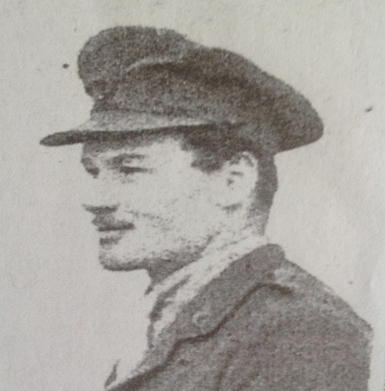
John Arthur Talbot Rice

CHELTENHAM CHRONICLE 24 MARCH 1917
Military Crosses
Hodson. Lieut (Acting Capt). Francis Lord Charles Charlton, Gloucestershire Regt, son of Rev Thomas Hodson of Oddington.

CHELTENHAM CHRONICLE 28 JULY 1917
News has been received of the death in action in July 10th of Sec Lieut Arthur Clements Heberden KRR, youngest son of the late Rev H B Heberden, rector of Oddington, Glos

