ODDINGTON WORLD WAR 1 ARCHIVE

1919 - 1921

- In a General Election women over 30 were allowed the vote for the first time.
- although an armistice was agreed in November 1918, it was not until 28 June 1919 that the Treaty of Versailles was signed between the Allied powers and Germany, thus officially ending the war 'to end all wars'. Further treaties with the other defeated Central powers followed through 1919 and, in the victorious countries, public celebrations marked the end of hostilities
CHELTENHAM CHRONICLE 14 JUNE 1919
Croix de Guerre has been awarded to Lindsay Bt Major G H M KSOB of Oddington.

CHELTENHAM CHRONICLE 18 JANUARY 1919
Capt Dudley Johnson DSO 2nd Battalion South Wales Borderers of Fern Bank Oddington has been awarded a Bar to his DSO

CHELTENHAM CHRONICLE 5 JANUARY 1919
The Return of Lt Col Dudley Johnson VC
A large crowd assembled at Addlestrop station on Monday afternoon to welcome Lt Col Dudley Johnson VC DSO (and bar) MC 2nd Batt 24th Regt (South Walws Borderers) attached 2nd Batt Royal Sussex Regt on his returning to Oddington. The station was beautifully decorated under the direction of Mr Harris (the station master). An arch with the words ‘Welcome to our VC’ and a large photograph of Col Johnson underneath was much admired. On the arrival of the train hearty cheers were given as Col Johnson – accompanied by his wife and little son and also by his younger brother Lieut Eric Johnson RN who has just returned from the Black Sea – alighted and having received many congratulations were conducted to a carriage which was then pulled by many willing hands of returned soldiers and others in a procession round the village which was gay with flags, the bells merrily ringing and continued cheering all the time, up to the residence of his mother , where, after a speech from Col Johnson, the company dispersed. Col Johnson is only back on short leave and returns to the Rhine on Tuesday.

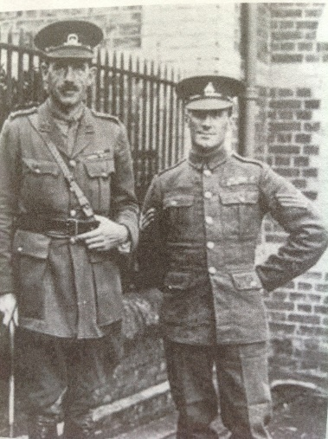
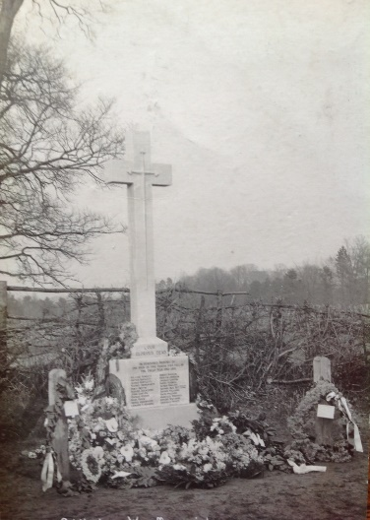
Dudley Johnson (left)

CHELTENHAM CHRONICLE 6 SEPTEMBER 1919
Oddington Soldiers welcomed home
A supper to returned service men organised by Mr Overington and Mr T Smith was held at the club room at the Railway Hotel on Saturday evening August 23. An excellent spread was provided by Mr and Mrs Miles and about 30 sat down to enjoy the good things provided. After the usual toasts the men repaired to the smoke room were a good concert was held. Some capital songs were rendered by several of the company among the soloists being Messrs Ridley, Smith, Bustin, Pawling, Williams, Gardiner, Overington, Keen etc and great fun was caused throughout the evening by Mr C Hall who is a born comedian. In the unavoidable absence of Mr C Johnson, the chair was taken by Mr Pawling of Addlestrop, the former coming in later and bringing his brother, Lieut- Col Dudley Johnson V.C. The company felt highly honoured by their presence. Many thanks were due to the host and hostess and the Misses Miles who helped to make the evening a success and to Mrs Smith and Mrs Overington who kindly help wait etc. After a most enjoyable time the company dispersed at about 10 pm feeling very pleased and elated with the evening’s entertainment

CHELTENHAM CHRONICLE 5 MARCH 1921

ODDINGTON WAR MEMORIAL UNVEILED

In memory of 22 men of Oddington who gave their lives for their country in the Great War a memorial cross was unveiled by Colonel Dudley Johnson VC, DSO, MC on Saturday afternoon in brilliant sunshine before a large crowd of parishioners and visitors.
The proceedings commenced with an assembly of the parishioners, choir and ex servicemen at Fern Bank, Upper Oddington, the residence of Mrs Johnson. After the ex servicemen had been inspected by Captain Harry Talbot Rice of the Welsh Guards a procession was formed, headed by the Choir, followed by the clergy, ex servicemen, girl guides and parishioners marched through the village to Lower Oddington, round the village green and back to where the cross was erected, just opposite Oddington Church.
Among others present were: Mrs Johnson, Miss Johnson, Lieut Col Victor Johnson DSO, Gloucester Regiment, Capt Raymond Johnson DSO, Lieut Eric Johnson RN, Mr Cecil Johnson (churchwarden), Mrs Dudley Johnson, Mrs Raymond Johnson, Mr and Mrs Talbot Rice (Oddington House), Capt Harry Talbot Rice, Mr David Talbot Rice, Mrs Greenwood, Capt and Mrs Barton, Capt and Mrs Curtis, Miss Cholmondeley, Miss Dawkins, Mrs and the Misses Heberden, Mrs Joan Cattley with the Girl Guides, Mr and Mrs Loine, Mr Weguelin, Mr and Mrs Clifford, Mr Kempson, Mr Gardener, Mr and Mrs Wiltshire, Mr and Mrs Wyatt, Mr and Mrs Cox, Mrs Padbury, Mr and Mrs Franks, Mrs Williams, Mrs Smith, Mr Gorton, Mr Jas Williams, Mrs Bartlett, Mr and Mrs Webb, Mrs Lupton and a very large congregation. Mrs Lindsey played the organ for the service. Col Dudley Johnson, after opening the service with an impressive address on the call to arms and self sacrifice and patriotism of the fallen soldiers, unveiled the memorial.
It is a plain stone cross on three steps, a crusaders sword in the shape of a cross being carved in the cross itself while the inscription on the upper stone of the base is as follows:
‘Our Glorious Dead – in honoured memory of the men of this parish who fell in the great War 1914 – 1919.
After prayer by the vicar (Rev A Cattley) and a hymn by the congregation an address was given by Chaplin Rev E T Murray of Bourton on the Hill followed by an address by Rev A Williams, the local nonconformist minister. And then the ‘Last Post’ and ‘Reveille’ were sounded by a trumpeter from the Welsh Guards, and relatives and friends deposited their floral tributes on the base of the cross. Among others a wreath brought by Messrs’ G S Salisbury and Eyland from the Moreton branch of the Comrades of the Great War.
