Evenlode Vale Churches
Seven Parishes United for the Future
Adlestrop, Bledington, Broadwell, Evenlode,
Icomb, Oddington and Westcote

30th March 2020
Dear Friends,
As you probably know we have had to heed the advice of the Church of England to close all our church buildings for the foreseeable future.
We are still able to offer opportunities for worship and other spiritual resources and hope that you will find these a source of encouragement in difficult and uncertain times.
Members of our team are recording a service for this Sunday (Palm Sunday) and we will upload it onto our website (www.evenlodevalechurches.org) together with short orders of service. We are also planning to live stream the service at 10.30am on Sunday morning which you will be able to access from the Spiritual Resources page of our website.
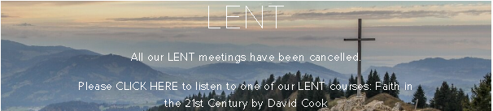
Sadly we have had to cancel all our Lent meetings but David Cook has recorded his 4 sessions on ‘Finding Faith’ in the 21st Century and you can listen to these by visiting our website and clicking on the Lent banner on the homepage. Alternatively you can go straight to the page by clicking on the link below: https://www.evenlodevalechurches.org/lent-programme-revised.
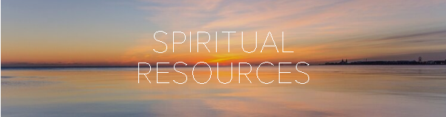
There are other resources available which you can access on the Spiritual Resources page of the website or by clicking the following link: https://www.evenlodevalechurches.org/spiritual-resources
We will be producing more resources over time as a source of hope in hard times, and will keep you updated as to what is on offer.
With love and prayers,
Richard – Rector of Evenlode Vale Churches

