Adlestrop, Bledington, Broadwell, Evenlode, Icomb, Oddington, Westcote

Dear Friends,

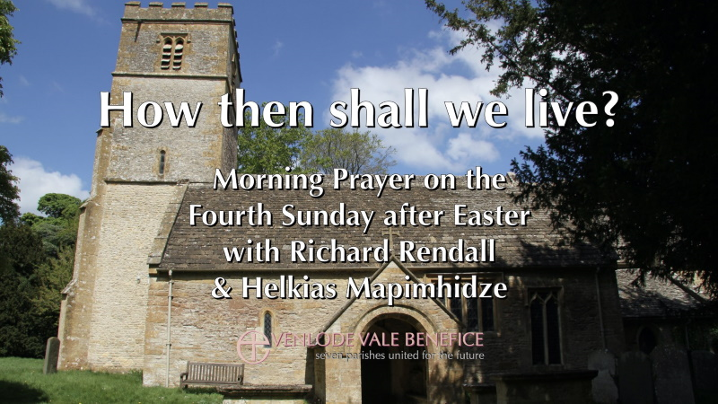
Sunday 10th May 2020

We invite you to join us for our live streamed service on Sunday at 10.30am recorded at St Paul’s Broadwell and led by Revd Richard Rendall. In the Sermon our Preacher Revd Helkias Mapimhidze summarises the blessings outlines in Paul’s letter to the Ephesians thus far and asks the question ‘How then shall we live?’

You can access the service via our website (www.evenlodevalechurches.org) or by using this link (https://youtu.be/I2VEP48sedQ). If you can’t join us at 10.30 am we will keep the service on our YouTube Channel so that you can watch it later.

You can download an order of service and a sermon transcript from the Spiritual Resources page of our website: https://www.evenlodevalechurches.org/spiritual-resources.
Please feel free to download and print for others who can’t access online resources.

Daily Readings
We have introduced daily readings published each Friday for the coming week. These are designed to be deliberately short and thought-provoking to help us through these challenging times. The readings can be read online or printed off to give to those who don't have internet access. Please do help your neighbours who find it hard to access online resources.
You can find readings using this link for 10th to 16th May and each Friday we will publish a fresh set for the coming week. The Daily Readings are available on the Spiritual Resources page of our website (address above).

Richard Rendall
Rector – Evenlode Vale Churches

