MEN ON ODDINGTON WAT MEMORIAL

Frederick Lee Clifford was serving as a Private with the 5th (Territorial) Battalion, The Oxfordshire & Buckinghamshire Light Infantry when he died of natural causes in the Radcliffe Infirmary on 3rd December 1939. He was aged 25 and is buried in St Nicholas Churchyard.
Herbert Henry Clifford was serving as a Private with the 5th (Territorial) Battalion, The Oxfordshire & Buckinghamshire Light Infantry when he died on active service in Northern Ireland on 21st June 1941. He was aged 21 and is buried in St Nicholas Churchyard.
Both Frederick and Herbert were the sons of Henry and Florence Clifford of Upper Oddington. Henry worked as builder's labourer and had served in France in the First World War as a motor driver in the Army Service Corps.
Francis George Gardiner was serving as a Private in the 4th (Territorial) Battalion, The Oxfordshire & Buckinghamshire Light Infantry when he was killed in action on 22nd May 1940. He was aged 26 and is buried in Bruyelle War Cemetery in Belgium.
Francis was a territorial soldier with the 4th Ox & Bucks which were sent to join the British Expeditionary Force (BEF) in France in January 1940. When the German Army launched their invasion of the Low Countries on 10th May 1940, the BEF withdrew west towards the Dendre river and then withdrew further towards the Scheldt river. The 4th Ox and Bucks were involved in action along the line of the River Scheldt (Escaut), south of Tournai. Private Gardiner was killed in action during the engagement.
Eric Gardiner, younger brother to Francis, was serving as a Gunner with “E” Troop, 246 Battery of the 62nd Anti-Tank Regiment, The Royal Artillery when he killed in action on 6th July 1944. He was aged 20 and is buried in St. Manvieu in Normandy.
246 Battery were equipped with 17 pounder guns towed by converted Crusader tanks, and Gunner Gardiner was a driver of the tank. They sailed from Tilbury on 5th June 1944 arriving off Mine Red Beach, Juno Beach at 1400 on D-Day 6th June. They waited to be called onto the beach and were bombed during the night but with no casualties. The eventually went ashore on 7th at 1730 and were soon in action in support of the Canadian 3rd Infantry Division. As part of a defensive outpost they beat off an attack by Panzer Grenadiers of the 12th SS Hitler Youth Division, suffering heavy casualties.

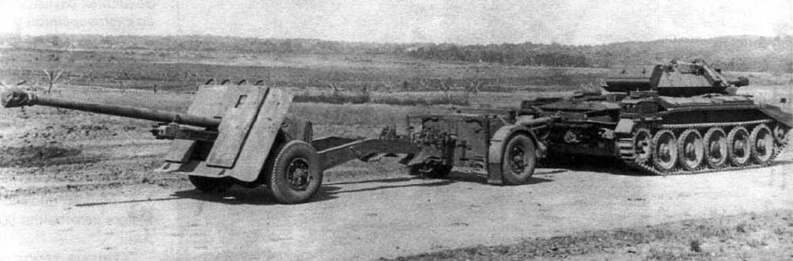
A 17 pounder anti-tank gun towed by a Crusader tank

On 4th July “E” Troop supported the 8th Canadian Infantry Brigade on an assault to capture Carpiquet
Airfield. Against heavy resistance the Canadians managed to advance into the shattered village of
Carpiquet. “E” Troop followed them in ready to support the next assault. At 2100 on Gunner Gardiner was killed during shelling of their positions in the village.
Francis and Eric Gardiner were the sons of William and Miriam Gardner of Upper Oddington where William worked as a farm carter and a cowman.
Hubert Leslie Hanks was serving as Corporal in the 2nd Battalion, The Glasgow Highlanders, Highland Light Infantry (City of Glasgow Regiment) when he died of his wounds on 16th June 1944. He was aged 30 and is buried in Bayeux War Cemetery.
The 2nd Battalion of the Glasgow Highlanders was a Territorial served in England as part of the 46th
(Highland) Infantry Brigade, 15th (Scottish) Infantry Division. They arrived on the Normandy beaches on 13th June 1944. The battalion fought in the Battle of Normandy in Operation Epsom and the Second Battle of the Odon, during which Corporal Hanks was mortally wounded.
Hubert was the son of William and Emma Hanks of Upper Oddington. He married Dorothy Mary Couling, of Lyneham in June 1939, living at The Leys in the village and working as a hardware salesman.
George Albert Peters was serving as a Leading Supply Assistant on HMS Glorious, The Royal Navy when he was killed on active service on 8th June 1940. He was aged 26 and is commemorated on the Plymouth Naval Memorial, his body not being recovered from the sea.

HMS Glorious was the second of the three Courageous-class battlecruisers built for the Royal Navy during the First World War. She was rebuilt as an aircraft carrier in the 1920s. After the start of the Second World War in 1939, Glorious spent the rest of the year unsuccessfully hunting for the commerce-raiding German cruiser Admiral Graf Spee in the Indian Ocean before returning to the Mediterranean. She was recalled home in April 1940 to support operations in Norway. While evacuating British aircraft from Norway in June, the ship was sunk by the German battleships Scharnhorst and Gneisenau in the North Sea with the loss of over 1,200 lives, including LSA Peters.
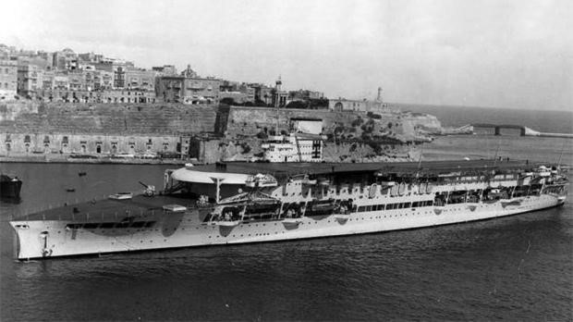

HMS Glorious

He was the son of Thomas and Ethel Peters, sub-postmasters at Lower Oddington.

Claude Vernon Sedgley was serving as a Private in A Company, the 4th Battalion (The Royal East Kent Regiment) when he was killed on active service on 24th October 1943. He was aged 26 and is commemorated on the Athens Memorial, having no known grave.
The 4th Battalion Buffs was a 1st Line Territorial Army unit that served with the BEF in France 1940. The battalion was transferred to the island of Malta in 1941 and served throughout the siege. The battalion then joined the 234th Infantry Brigade, which took part in the disastrous Battle of Leros in an attempt to capture the Dodecanese Islands in late 1943.
Private Sedgley had embarked on the destroyer HMS Eclipse bound for Leros when she hit a mine east off Kalymnos. She broke in two and sank within five minutes with the loss of 119 of the ship's company and 134 soldiers from A Company, 4th Battalion, Buffs (Royal East Kent Regiment).
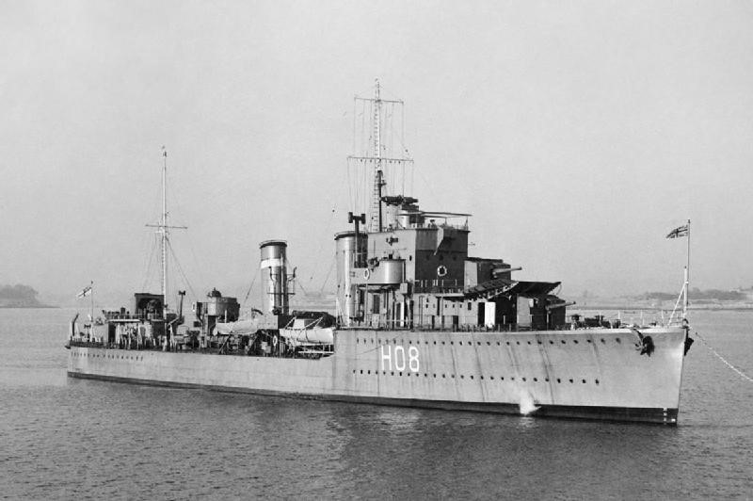

HMS Eclipse

Richard Henry Sedgley was serving as a Sergeant, Air Gunner, the Royal Air Force, when he died on active service on 12th January 1945. He was aged 19 and is buried in Oddington St Nicholas Churchyard.
He had enlisted into the Royal Air Force Volunteer Reserve in 1944 and was training as an air gunner. He was completing his training with No 5 Lancaster Finishing School when on 12th January he took off from RAF Syerston in Nottingham aboard Avro Lancaster III, JB125, A5-H on a night training exercise. After a 3 hour flight the Lancaster returned to Syerston but encountered failing visibility, low cloud and drizzle. At about 0950 the aircraft overshot the runway and whilst banking flew into the ground near the village of Hoveringham, killing all 7 aircrew.
Claude and Richard were the sons of George and Kate Sedgley of Upper Oddington. There is a photo of Richard and Claude as young boys in 20th Century Oddington Book.

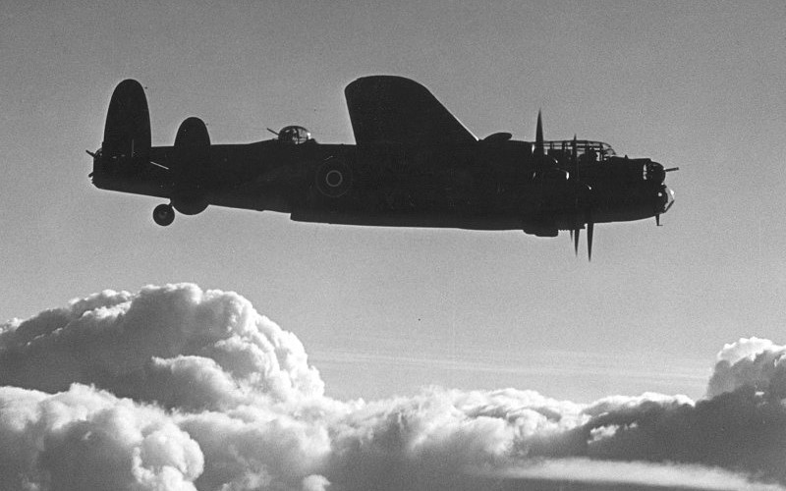

An Avro Lancaster of 5 LFS

