Adlestrop, Bledington, Broadwell, Evenlode, Icomb, Oddington, Westcote

Dear Friends,
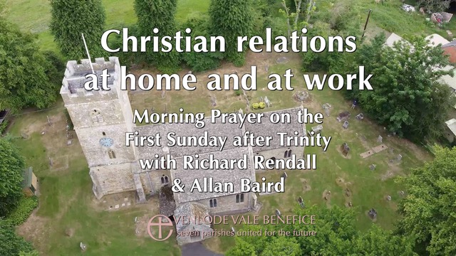
Sunday 14th June 2020 at 10.30am
We invite you to join us for our Service this Sunday, recorded at the Church of St Edward, King & Martyr, in Evenlode. Our speaker, Allan Baird will give a talk entitled: ‘Christian Relations: At home and work’.
You can access the service via our website (www.evenlodevalechurches.org) or by using this link (https://youtu.be/u6nsnXzDMos).
Worksheet for Children
If you have children you can download a worksheet based on the sermon passage using the link below. Please let us know if you find this additional resource helpful.
You can download an order of service, hymn sheet, sermon transcript and children’s worksheet from the Spiritual Resources page of our website: https://www.evenlodevalechurches.org/spiritual-resources.
Daily Readings
You can view the readings for 14th to 28th June from this link: https://www.evenlodevalechurches.org/s/Daily-readings-June-14th.pdf

Private Prayer
We are pleased to say that we are opening our Parish Churches for Private Prayer as from Monday 15th June. St Nicholas, Oddington will open as from Wednesday 17th June to allow for the filming of next Sunday's Service and Holy Ascension will remain closed for the time being. There will be leaflets in our churches to help guide us in private prayer.
Please keep the leaflet after use and bring it back with you if you wish to return. Please use the hand sanitiser provided when you enter and leave the church and avoid using the church if you currently have symptoms of Corona-virus infection.
Richard Rendall
Rector – Evenlode Vale Churches

